**MINIMARKET CASHIER PROGRAM PROJECT REPORT USING JAVA LANGUAGE**



**Arranged by :**

**Amiril 2341760171**

**Azaria Cindy Sahasika 2341760169**

**Muhammad Faruq 2341760197**

**BUSINESS INFORMATION SYSTEMS STUDY PROGRAM**

**DEPARTMENT OF INFORMATION TECHNOLOGY**

**MALANG STATE POLYTECHNIC**

**ACADEMIC YEAR 2023/2024**

1. Features of the Minimarket Cashier Program
2. Selection of items to be purchased
3. Selection of the number of items to be purchased
4. Selection of whether the customer has a member card (for discount calculation)
5. Selection of payment method (cash, credit/debit card, or digital payment).
6. Selection and Condition
7. Selection of items

The user selects the items to be purchased from the list of available items. The condition required is a valid selection of items, and the action will depend on the items selected.

1. Item quantity selection

The user selects the quantity of goods to be purchased. The required condition is the selection of the appropriate quantity of goods (cannot be negative or over stock).

1. Member card selection

If the customer has a member card, the program needs to provide a special discount, the required condition is whether the customer has a member card or not.

1. Payment method selection

The customer selects a payment method (cash, credit/debit card, or digital payment). The required condition is a valid payment method.

1. Flowchart

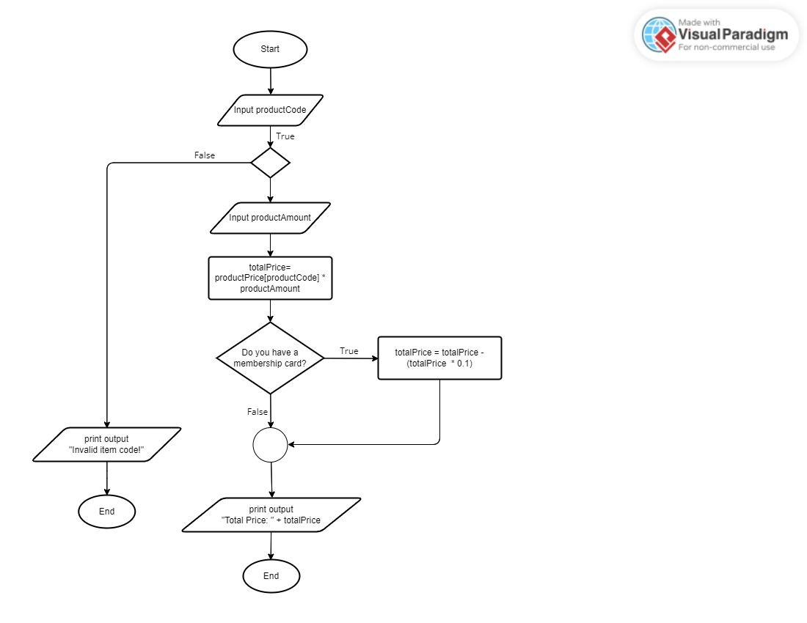

1. Code and Output

